**CHAPTER 8**

**RESULTS AND DISCUSSION**

**Original Signal**

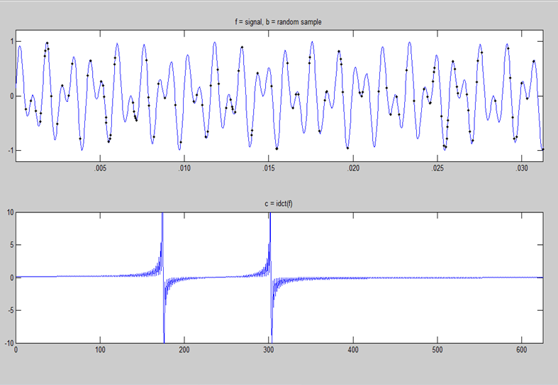

Figure 8.1

Top: Random samples of the original signal generated

Bottom: The inverse discrete cosine transform of the signal

Our example uses the discrete cosine trans­form (DCT) as the basis. The signal generated by the user is the sum of two sinusoids with incommensu­rate frequencies, are given thousands of weighted averages of millions of signal. Our job is to re-generate the original signal. The above figure shows the following details:

1. The graph at the top represents input analog signal with the black dots representing the samples that are taken into consideration.
2. The bottom graph represents the inverse direct cosine transform (IDCT) of the input signal which are represented as two sinusoids.

**Orthogonal Matching Pursuit Solution**

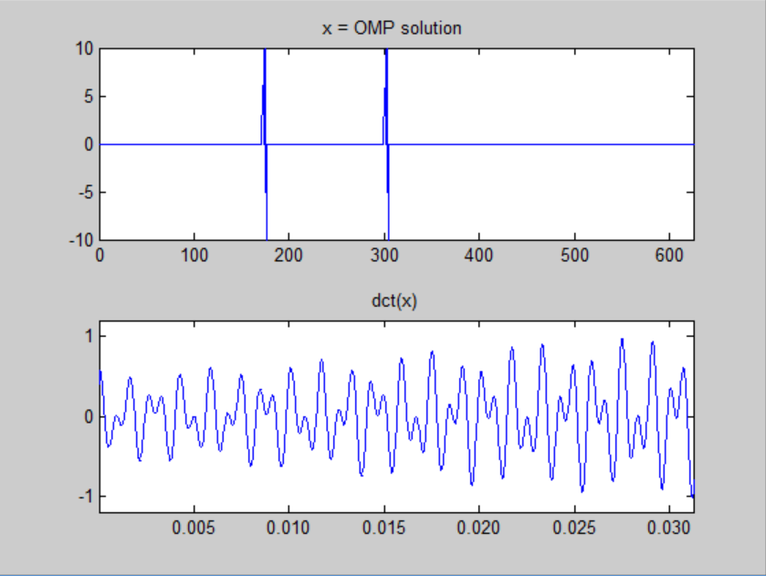

Figure 8.2

Top: OMP solution of the original signal

Bottom: Reconstructed signal using OMP

The above figure shows the following details:

1. The graph at the top shows the OMP solution of the original signal.
2. The graph at the bottom is the reconstructed signal using the Orthogonal

Matching Pursuit.

**Basis Pursuit Solution**

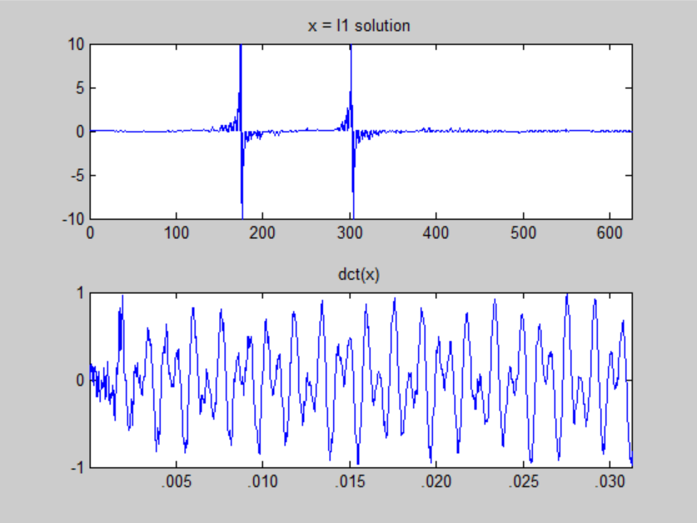

Figure 8.3

Top: L1 solution of the original signal

Bottom: Reconstructed signal using Basis Pursuit

The above figure shows the following details:

1. The graph at the top shows the L1 solution of the original signal.
2. The graph at the bottom is the reconstructed signal using the Basis Pursuit scheme.

**Approximate Message Passing Solution**

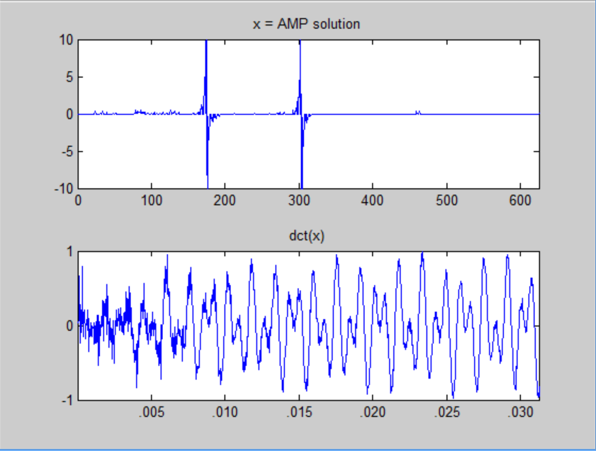

Figure 8.4

Top: AMP solution of the original signal

Bottom: Reconstructed signal using AMP

The above figure shows the following details:

1. The graph at the top shows the AMP solution of the original signal.
2. The graph at the bottom is the reconstructed signal using the Approximate

Message Passing.

The values of error rates for the three schemes are calculated as:

$$\sum_{i=0}^{n}{{(x}_{i}-f_{i})×(x_{i}-f_{i})}$$

|  |  |  |  |
| --- | --- | --- | --- |
| Input key | Orthogonal Matching pursuit | Basis Pursuit | Approximate Message Passing |
| 0 | 0.4638 | 0.4798 | 0.4756 |
| 1 | 0.4578 | 0.4796 | 0.4772 |
| 2 | 0.4637 | 0.4786 | 0.4725 |
| 3 | 0.4669 | 0.4563 | 0.4596 |
| 4 | 0.3805 | 0.4627 | 0.4784 |
| 5 | 0.4519 | 0.4693 | 0.4679 |
| 6 | 0.3685 | 0.4788 | 0.4809 |
| 7 | 0.4844 | 0.4647 | 0.4642 |
| 8 | 0.4891 | 0.4844 | 0.4791 |
| 9 | 0.4165 | 0.4815 | 0.4834 |

Table 8.5 Error Rate

**Comparison of Error Rate**

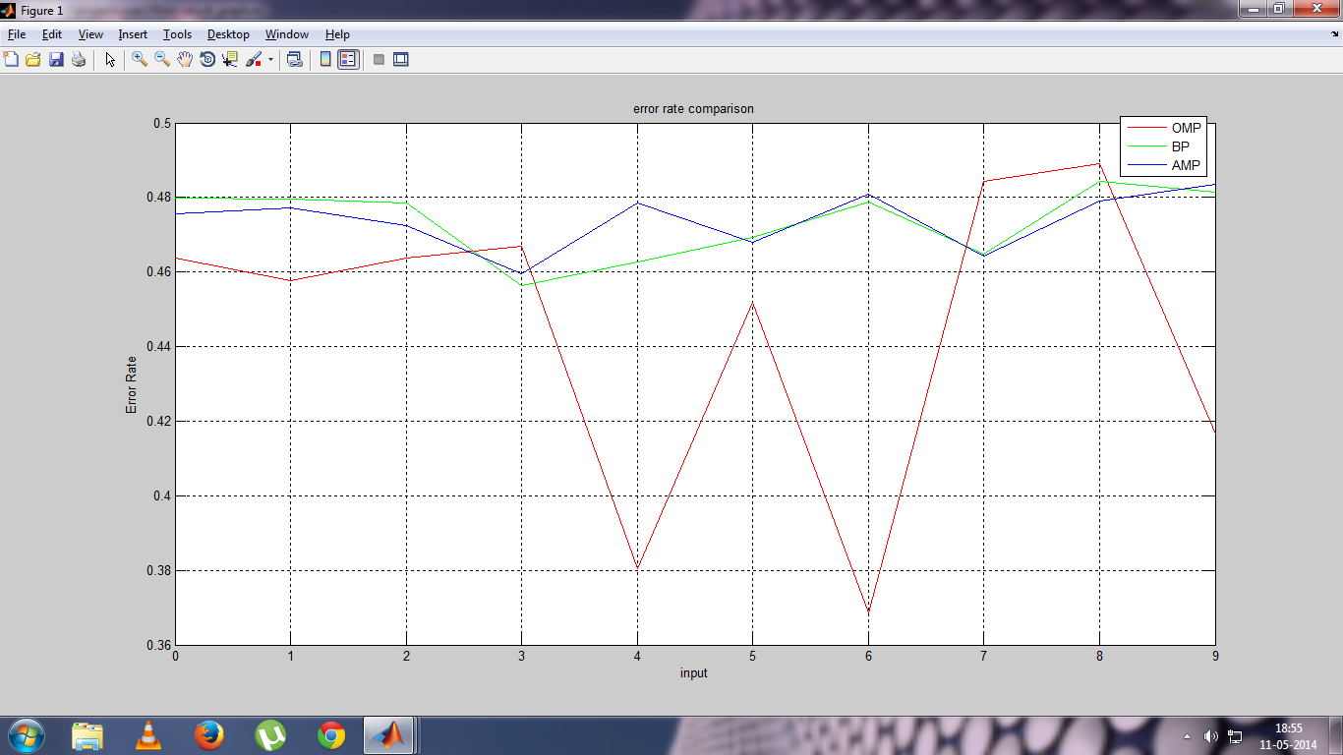

Figure 8.6 Comparison of Error rate

Average error rate for

1. Orthogonal Matching Pursuit (OMP) is 0.4443
2. Basis Pursuit (BP) is 0.4736
3. Approximate Message Passing (AMP) is 0.4739